The Thuya Burl story

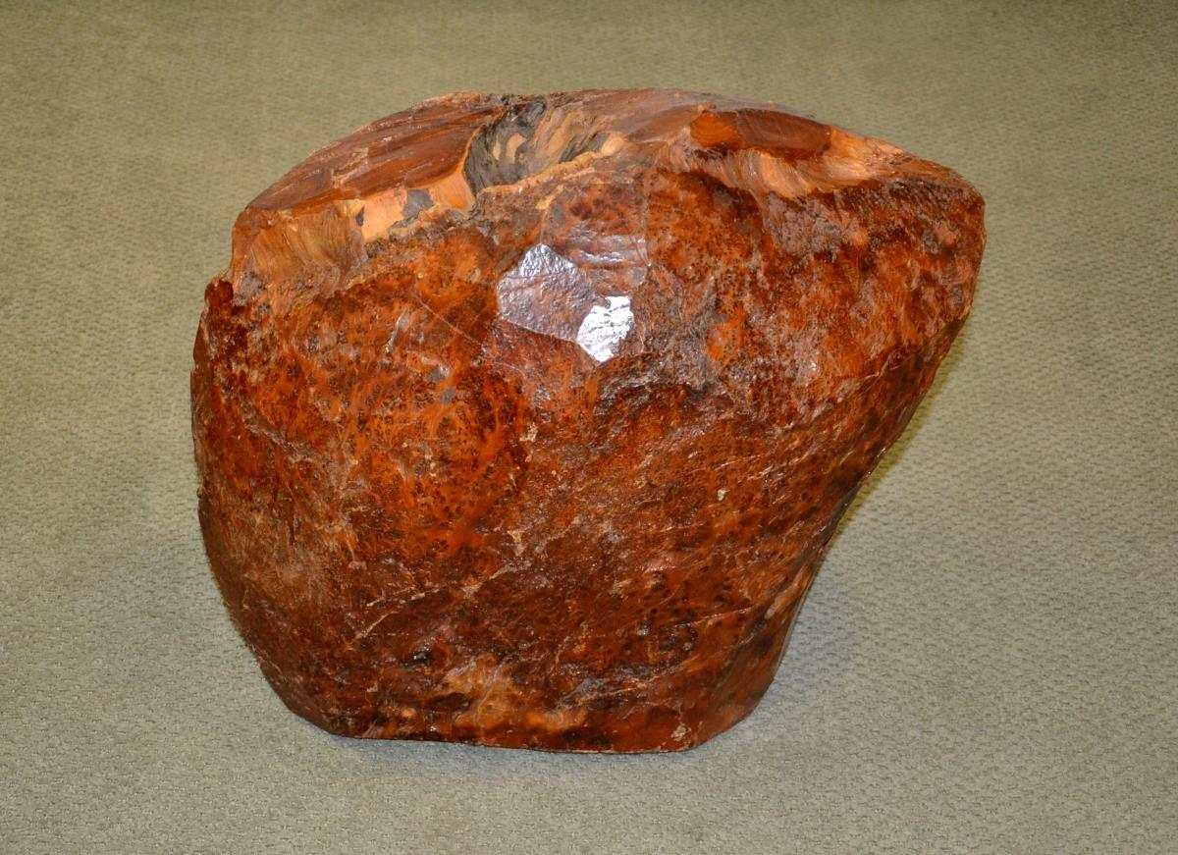
THIS IS THE 80 POUND BURL AS IT WAS WHEN I FIRST SAW IT IN 1987
I first saw this thuya burl in 1987 when I visited the Windsor Plywood Store on King Edward St. I was captivated with it, and tried to buy it. It weighed 80 pounds and they wanted a LOT of money for it. I offered them a bit less less, and they turned me down.
Several years later, I was teaching woodturning at Lee Valley Tools. At one of my beginner classes I met Mike Walter, and we became friends. Mike would visit in my shop often and take lessons from me or just hang out.
We quickly formed a friendly rivalry in almost everything. I bought a new lathe, he bought a bigger one. I bought a new chain saw – he bought the next size up. His favorite comment was, “my chainsaw is bigger than yours.”
I told Mike about the thuya burl, which was still on display at Windsor Plywood. I told him what I had offered for the burl several years prior, and a few days later he called to say he had purchased the burl for less than I had offered. He had it on pedestal in his living room, and now he had something new to brag about. He never missed an opportunity when we were with woodturning friends to rub it in. “I have a thuya burl on a pedestal in my living room”. Another good friend, Ed Tabachek, thought it was great fun to join in.
But he never did anything with it, and I would bug him. “Mike, when are you going to turn that burl?”
“Don’t worry Herm, when I do I will save you a piece, har-har.”
Ed and Mike and I would get together for coffee every Wednesday. Ed was retired and Mike would take time away from his job to join us. We Three Musketeers enjoyed each other’s company.
Then, Ed got leukemia and fought a hard battle to recover from it. As he was apparently getting better, Mike told us one day he had been diagnosed with throat cancer, and the two of them had a different bond than either of them wanted. But, as close friends we continued to meet for coffee as often as we could. For quite a while, after surgery and chemo it appeared Mike was going to beat his cancer too.
Mike called one day.
“Herm, the cancer is spreading, and I have some decisions to make. I do not have the skill and experience to do anything with that burl, and I have had my fun teasing you with it. It is now time for you to have it, and if I just get my money back, it is yours. I trust no other woodturner with it.”
That touched my heart. I cheerfully paid him for it, and promised him that when I cut into that burl he and Ed had to be there too so they could harass me the whole time. And I parked that burl in the shop with no clue of how to cut it most efficiently. You see, once the cut is made, one is committed.
It sat there for a couple of years, and then Ed suddenly died. Told by the doctors his cancer was gone on Monday, and died of cancer on Thursday. We attended his funeral and Mike appeared thin and withdrawn, and I knew he was thinking that soon it would be him.
I last spoke to Mike shortly before we left for our winter vacation in 2015. When I returned three months later I called his home, and his wife told me he had passed over the winter.
Neither he or Ed had seen me cut into the burl, and I felt badly for procrastinating. So, at a local club meeting I told the group the burl was going to be cut, and I wanted some of them to stand in for Ed and Mike and to come ready to harass me like they would. And we would toast the two of them.
Five guys showed up, with video cameras and armed with verbal barbs about everything I did. “You’re not holding the chain saw right.” “Don’t cut there!” “Do you even have a CLUE what you’re doing?”
It was fun, tinged with sadness, but the beautiful aroma of cedar soon filled the air.
So, that is the story, and the end has not yet been written. A piece of that story belongs to the piece you now have, and I would like the story to remain part of it.
And a part of Ed, and especially Mike.

- Herman de Vries

